**Laporan Jobsheet 6**

**Pemrograman Berorientasi Objek (PBO)**

**Percobaan 1 : Dasar-Dasar Inheritance**

* Buat project baru dengan nama **HewanOOP1**

* Buat superclass **Hewan**

* Buat subclass **Kucing**

* **Tugas Praktikum:** Buatlah subclass lain, misalnya Anjing, yang mewarisi dari Hewan dan memiliki metode menggonggong().

* **Output** :

**Percobaan 2 : Menggunakan Method Overriding**

* Perbarui project **HewanOOP1**

* Superclass **Hewan**

* Subclass **Kucing**

* Subclass **Anjing**

* **Tugas Praktikum**: Òverride metode bersuara() di kelas Anjing agar menghasilkan output "Guk!".

**Percobaan 3 : Konstruktor dan super()**

* Buat project baru dengan nama HewanOOP2

* Superclass Hewan

* Subclass Kucing

* Tugas Praktikum: Tambahkan atribut ras di kelas Kucing dan modifikasi konstruktornya agar menerima parameter ras. Pastikan konstruktor Kucing memanggil konstruktor Hewan dengan benar.

**Percobaan 4 :** **Multilevel Inheritance**

* Buat project baru dengan nama **HewanOOP3**

* Superclass **Hewan**

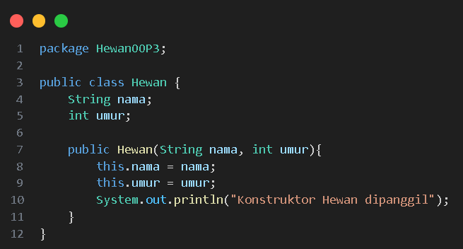

* Subclass **Mamalia**

* Sub-Subclass **Kucing**

* **Tugas Praktikum**: Buatlah subclass lain, misalnya Anjing, yang mewarisi dari Mamalia. Tambahkan metode atau atribut yang sesuai untuk Anjing.

**Percobaan 5 :** **Access Control dan super**

* Buat project baru dengan nama **HewanOOP4**

* Superclass **Hewan**

* Subclass **Kucing**

* **Tugas Praktikum**: Buatlah subclass lain, misalnya Anjing, yang mewarisi dari Hewan. Tambahkan metode atau atribut yang sesuai untuk Anjing, misalkan atribut jenisBulu yang bersifat private, dan metode getJenisBulu() yang bersifat public untuk mengakses atribut tersebut.

**Percobaan 6 :** **Abstract Class**

* Buat project baru dengan nama **KendaraanOOP**

* Superclass **Kendaraan**

* Subclass **Mobil**

* Subclass **Motor**

* **Tugas Praktikum**: Tambahkan subclass lain, misalnya Truk, yang mewarisi dari Kendaraan. Modifikasi kelas Kendaraan dan subclass lainnya sesuai kebutuhan.

**Kesimpulan**

Inheritance, konsep kunci dalam OOP, memungkinkan penggunaan kembali kode dari superclass, sehingga mengurangi duplikasi dan mempermudah pemeliharaan. Dengan super, subclass dapat mengakses anggota superclass dan memanggil konstruktornya.

Access control (public, private, protected) berperan penting dalam mengatur akses ke anggota kelas, menjaga enkapsulasi, dan mencegah perubahan yang tidak diinginkan. Inheritance sangat fleksibel, dapat diterapkan dalam berbagai kasus untuk memodelkan hubungan "is-a" antara kelas-kelas, menghasilkan kode yang lebih terstruktur, efisien, dan mudah dipahami.